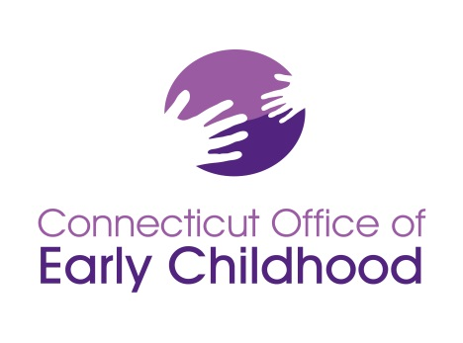
Connecticut Early Childhood Professional Registry
450 Columbus Blvd, Suite N304 • Hartford, CT 06103
800-832-7784 • www.ct.gov/oec

Identifying Qualified Staff Members (QSM) and Calculating Program Compliance

Part 1 of this document explains how to set up your program and keep it maintained (see General Policy GP A-03).
Part 2 of this document explains how to use INDIVIDUAL staff data in the Registry for PROGRAM QSM compliance (see General Policy GP A-01).
Use this document after reviewing the Instructions – Program Administrators on the homepage at www.ccacregistry.org.
Part 1: Setting Up and Maintaining Classroom and Staff Details of Your Program in the Registry
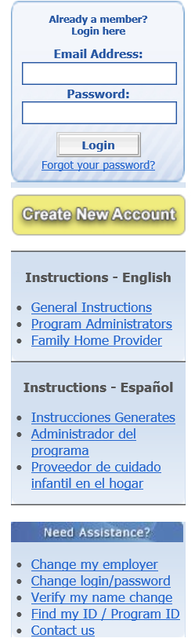
Please note that it is a requirement of your grant to keep your program information up to date. It is expected that you will (a) enter and / or send in all necessary information within 30 days and b) confirm your program data on a monthly basis. Registry staff will NOT be responsible for substantive changes close to program grant deadlines. It is the program’s responsibility to ensure information is kept current and sent to the OEC on a timely basis. Refer to GPs A-01 & A-03.Please follow these steps to ensure your program data is current:

- Go to the OEC Registry: www.ccacregistry.org
You must have administrative access to view the program tools. If you do not yet have access, (a) be sure your program name is showing as your employer and (b) follow the Instructions – Program Administrators to complete the Admin Access form and request access properly.
If you are the program administrator of multiple sites, you will need to request administrative access to all sites (multi-site administrative access or MSA access). Note that your name and qualifications will only show on the reports for your program on your account. NAEYC, OEC program grant managers, and liaisons know this. You will need to show reports from your primary employment site to verify meeting qualifications.
For both admin access and MSA access, as part of the electronic application via your Registry account, you MUST submit the Admin Access form signed by a supervisor (or owner) authorizing your access and listing each site specifically. The Admin Access form is on the homepage prior to log in under Program Administration.
If you have questions on how to use the Registry as a program administrator, return to the Instructions – Program Administrators on the Registry homepage. These outline key functions accessible only to those with administrative / MSA access.

- After logging in with administrative access, click on the Program Administration tab on the left menu.

- You will then view a tools menu for each program for which you have program administrator access.
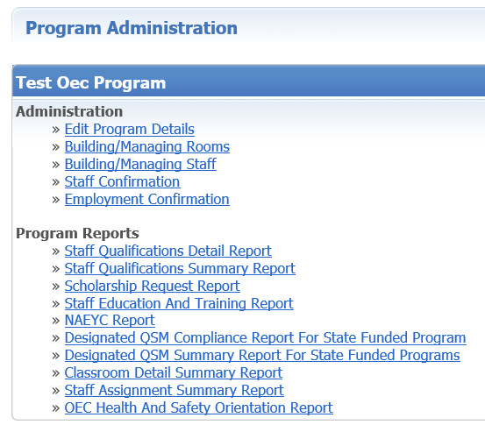

- First go to Edit Program Details to ensure all the information is accurate.
- Contact your OEC Program Grant Manager to correct any locked state funding; Contact your OEC Registry’s regional Education Advisor to correct any other locked information, including if your Care4Kids provider ID is not showing.

(b) Click Edit and check all funding your PROGRAM as a whole uses.
Later, in the Building/Managing Rooms function, you will be asked to choose from these options for the funding applied to each classroom / group. This section on Edit Program Details applies to the program as a WHOLE.

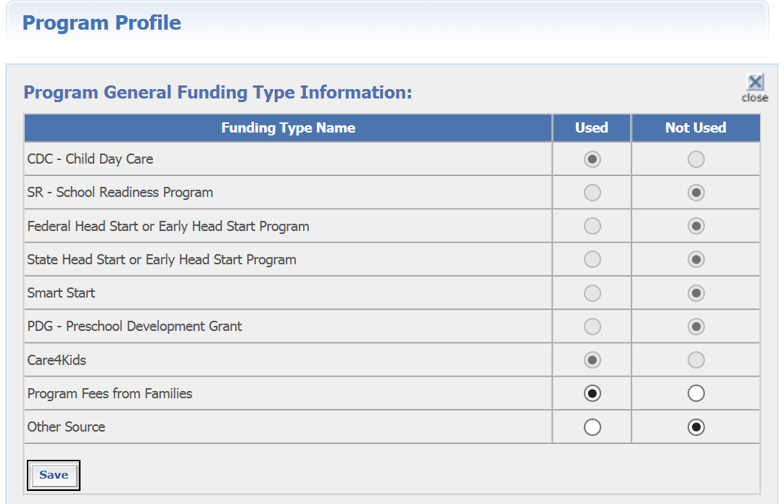
“Other Source” may be used for such items as municipal funds, scholarship, etc.

- Next, click on Staff Confirmation to ensure all staff listed currently work for your program, and their information is current.

  - The screen automatically begins by showing any unconfirmed staff in the pink section. If there are none, you will see a similar view to the one below. Note that the “Last Update” date shown here is the one used on the program reports where Last Update is visible. Other modules such as Building / Managing Rooms and Staff have their own page Last Update date, but those are not visible on reports.
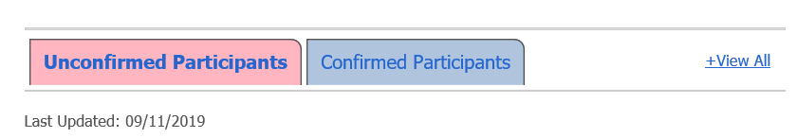
Click the blue “Confirmed Participants” section to open the list of previously confirmed staff.
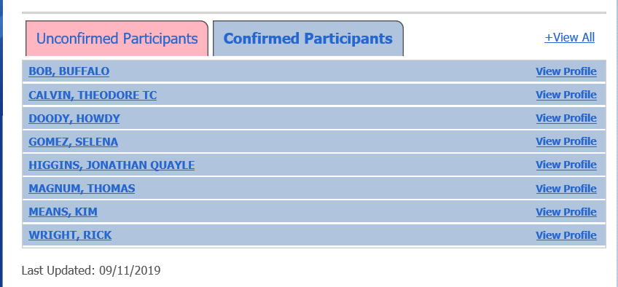
  - Each staff member’s name is a link to open their Staff Confirmation page data. When you click it, the entry expands. You can also click “+View All” to open all the entries at once.
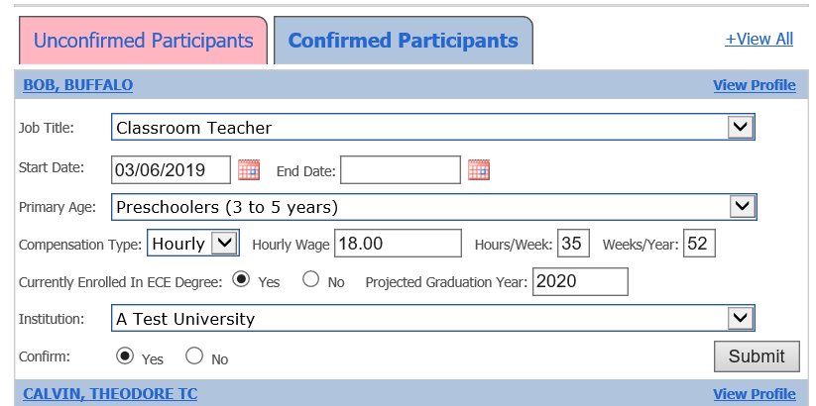

  - There is also a link on the right of each entry to view that staff member’s Registry profile. There you can view account details relevant to the staffer’s employment, and account details such as the email used for login. Note that fields are locked in your view and some content such as the correspondence log is hidden (protected by privacy law).
  - Be Aware: the Start Date field is for the current information – it changes from the date of hire as information changes. As you change wages or other key fields, the system will ask you to update this by entering the last date the old data was valid and the start date of the new data (i.e. last date the staffer made $15.00/hour and first date the staffer made $15.50). Old data is stored in the Registry.

  - The field “Currently enrolled in ECE Program” refers to enrollment in a degree program specifically in ECE. Be sure to also enter the projected graduation year and the institution. If the staffer is enrolled in a non-EC degree program, do NOT enter anything in these three fields.

  - Making and saving any change in a record, OR opening and clicking Submit in any record will change the last updated date. Whether or not you made updates, this will verify the last date your review was completed.

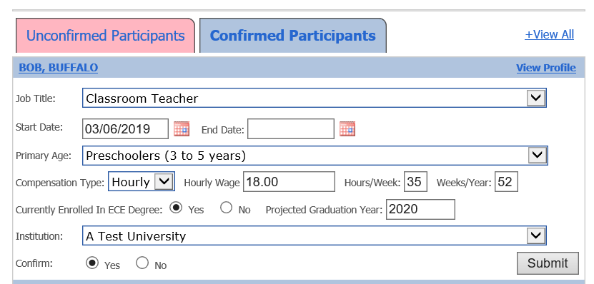

- Now you are ready to “build your program” with details of the classrooms/groups. Your work starts with the tab Building / Managing Rooms. When you click Add a Room, you will access a screen similar to the one below. We’ve included some notes to help.
- Do not name the room after a staff member! The name of a room is not editable. If you name a room after a staff member and that person leaves employment, you will need to DELETE the room and start a new one.
- The name of the classroom should be clear for an OEC representative visiting your program to easily find the rooms and staff assigned to them.
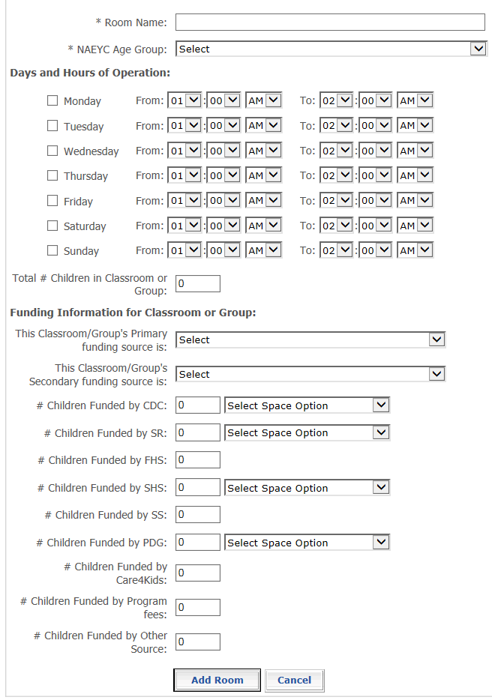
Please enter the TOTAL number of children. Do NOT enter the licensed capacity or full time equivalent. Enter the actual number of children in this classroom or group.
This section will only provide you with the options you or the OEC indicated are PROGRAM funding under Edit Program Details (see page 2).

- When you have built your classrooms / groups and are ready to assign the QSM, you will do so from Building / Managing Rooms by clicking on Manage Staff. This is specific to this room, as opposed to the Building / Managing Staff that shows for the whole program.
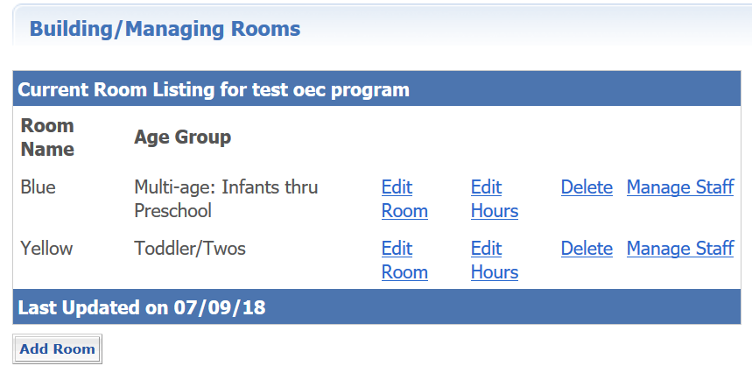
This screen then allows you to choose staff from your drop down of confirmed employees, and to identify the one eligible staff member from the auto-filled list of QSM.
- First, choose the Employee from the drop down, and the role for each staffer in each room.
- Remember the staffer to be designated as QSM must be in the role of Teacher to be a designated QSM. Your list will only show those confirmed staff you have tagged in the role of Teacher.
- The QSM list identifies the QSM expiration date for eligible Teacher assigned to that room to better assist you.
- The Employee drop down list will show staff in red who have not yet been assigned a role.

For a quick at-a-glance of how staff and QSM are assigned in rooms across the whole PROGRAM, click on Program Administration, then Building / Managing Staff.
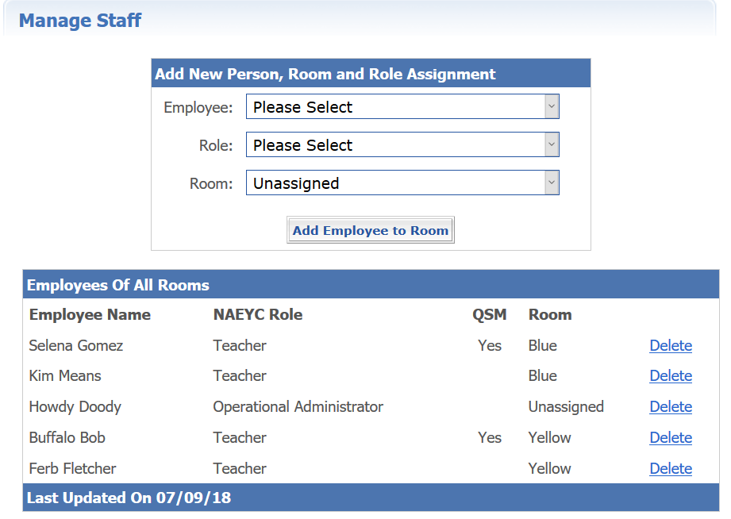

Remember the QSM expiration dates are listed on your Staff Qualifications Detail Report so you can assess picking QSMs who will help you meet PROGRAM compliance. Check the Designated QSM Compliance Report for State Funded Programs or the Designated QSM Summary Report for State Funded Programs to check your overall compliance.

Once you have completed these steps, you will only need to make changes as needed! Remember that you will have to update the Staff Confirmation page monthly to show that you are current with your program requirements.

Part 2: Taking Individual Designated QSM Data and Assessing Program QSM Compliance
The OEC Registry:
- Takes education data for each confirmed staff member and applies the current legislations.
- Confirms whether or not the individual is QSM eligible AND, if so, provides a QSM expiration date based on their qualifying education.
The OEC Registry does these automatically; you must designate the staffer as a Teacher and as QSM (see page 6).
This chart provides assistance at an INDIVIDUAL level. Meeting QSM and the expiration date are printed on each individual’s Education and Training Report and OEC Registry Membership Card (under My Tools and Settings). Admin Access / MSA Access users can view these details on the Staff Education and Training Reports and the Staff Qualifications Detail Report.
 | My education is: | Am I eligible? | How long am I eligible? | Next Steps
 | Less than a CDA credential AND 12 ece credits | Not yet | Not eligible yet | Apply for OEC Scholarship toward your ECE degree!
 | Current CDA credential AND 12 ece credits | Yes, for a little longer… | …until June 30, 2025 | Apply for OEC Scholarship toward an ECE degree!
 | Associates degree in any field AND at least 12 ece credits | Yes, but… | …until June 30, 2025 | Apply for OEC Scholarship toward your ECE bachelor degree!
 | Bachelor’s degree or higher in any field AND at least 12 ece credits | Yes, but… | …until June 30, 2025 | Apply for the ECTC (Early Childhood Teacher Credential) B Level Individual Review Route!
 | On 06/30/2015 I was grandfathered in the Registry as meeting the bachelor degree because I worked at my program since 1995 and had my associate degree | Yes, but… | …until June 30, 2025 | Apply for OEC Scholarship toward your ECE bachelor degree!
 | Associates degree in ECE, OR ECTC (Early Childhood Teacher Credential) - Associate level only (Traditional college route OR Individual Review Route) | Yes, but… | …until June 30, 2029 | Apply for OEC Scholarship toward your ECE bachelor degree!
 | On 06/30/2015 I had a bachelor degree + at least 12 ece credits in the Registry and was grandfathered as meeting the bachelor degree | YES! | You meet the goal! | Take advantage of quality professional development to keep your skills sharp and stay up to date with the latest ECE research and best practices.
 | Bachelor’s degree in ECE | YES! | You meet the goal!
 | ECTC (Early Childhood Teacher Credential) - Bachelor level only (Traditional college route OR Individual Review Route) | YES! | You meet the goal!
 | Current teacher certification in early childhood education | YES! | You meet the goal!

Legislation calls for the data of all designated QSMs to be summarized into PROGRAM compliance. Legislators created the following benchmarks for the program:

PA 19-34 (SB 932) Program Compliance Benchmarks and Details
A | B | C | D
Goal: All DQSMs have at least a CDA credential + 12 ECE credits | Goal: 50% or more DQSMs have at least an associate degree in ECE, AND the remaining percentage have a CDA credential plus 12 ECE credits | Goal: 50% or more DQSMs have a qualifying bachelor degree in ECE, AND the remaining percentage have an associate degree in ECE or an ECTC associate level (traditional or IRR) | Goal: 100% DQSMs have a qualifying bachelor degree in ECE
Until June 30, 2022 | July 1, 2022 to June 30, 2025 | July 1, 2025 to June 30, 2029 | From July 1, 2029 on
100% of DQSMs must be career ladder 7 or higher in the Registry, meeting one of the following:  - Current CDA credential plus 12 ECE credits  - Associate degree or higher plus 12 or more ECE credits  - Current teacher certification in ECE/Sp Ed  - Any grandfathered QSM status | At least 50% of DQSMs have one of the following:  - Current teacher certification ECE/Sp Ed  - ECTC (Early Childhood Teacher Credential) Associate or Bachelor level; traditional college route or IRR (Individual Review Route)  - Associate degree or higher specifically in ECE  - Any grandfathered QSM status | At least 50% of DQSMs have one of the following:  - Current teacher certification ECE/Sp Ed  - ECTC (Early Childhood Teacher Credential) Bachelor level only; traditional college route or IRR (Individual Review Route)  - Bachelor degree specifically in ECE  - Grandfathered QSM status with expiration 2099 | 100% of DQSMs have one of the following:  - Current teacher certification ECE/Sp Ed  - ECTC (Early Childhood Teacher Credential) Bachelor level only; traditional college route or IRR (Individual Review Route)  - Bachelor degree specifically in ECE  - Grandfathered QSM status with expiration 2099
 | Remaining % have:  - Current CDA credential plus 12 ece credits  - The OEC also recognizes any non-qualifying degree (not mentioned above; ladder level 9 or higher) | Remaining % have:  - Associate degree ece OR ECTC (Early Childhood Teacher Credential) Associate level; traditional college route or IRR (Individual Review Route)

Your Related OEC Registry Reports:
- The Staff Qualifications Detail Report (under Program Administration - Program Reports) provides a quick at-a-glance of INDIVIDUAL level detail.
For PROGRAM compliance:
- The Designated QSM Compliance Report for State Funded Programs tells how many classrooms are built in each possible age category, which have designated QSMs, QSM expirations summaries, and overall compliance. The OEC releases a version of this report without the classroom and QSM detail each month.
- The Designated QSM Summary Report for State Funded Programs provides a short at-a-glance of program compliance (see page 10).
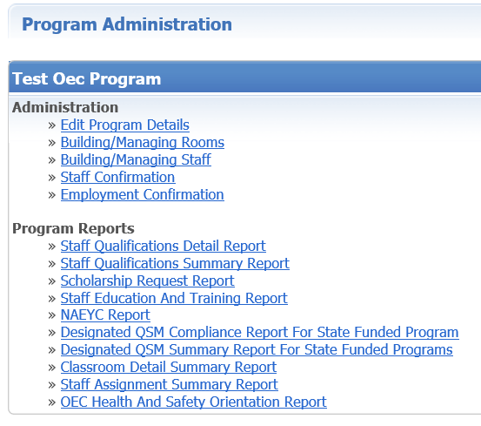
Additional Important Notes:
- Credential or Endorsement Expirations: Note that some staff may meet a QSM expiration date based on a credential or endorsement that expires, such as a CDA credential or Early Childhood teaching endorsement. The Registry automatically sends an email in advance of the expiration to warn the user so he/she can submit a renewal in a timely manner, and another email when the item expires. At expiration, the item is automatically deleted from the user’s account. QSM expiration can drop or change date based on this; which, in turn, can cause a program to show as noncompliant if that person was a designated QSM used to reach a benchmark. Don’t forget to send in renewals well in advance of expiration!
- Remember that your classrooms serving ANY combination of infants, toddlers or preschoolers PLUS designated QSM expirations are used to assess the benchmarks. Each I/T/PS classroom must have a designated QSM, not just the state funded classrooms.

Designated QSM Summary Report for State Funded Program
This report offers an at-a-glance of the designed QSMs and the program’s standing with each of the legislated benchmarks.
Note:
The QSM Expiration Date for each designated QSM in the first section
The number of eligible classrooms (serving any combination of Infant through Preschool aged children) and how many have designated QSM (this number must be at 100% in order for any benchmarks to show as met).
Finally, the Registry summarizes the data for each benchmark for all the designated QSMs and the classrooms.

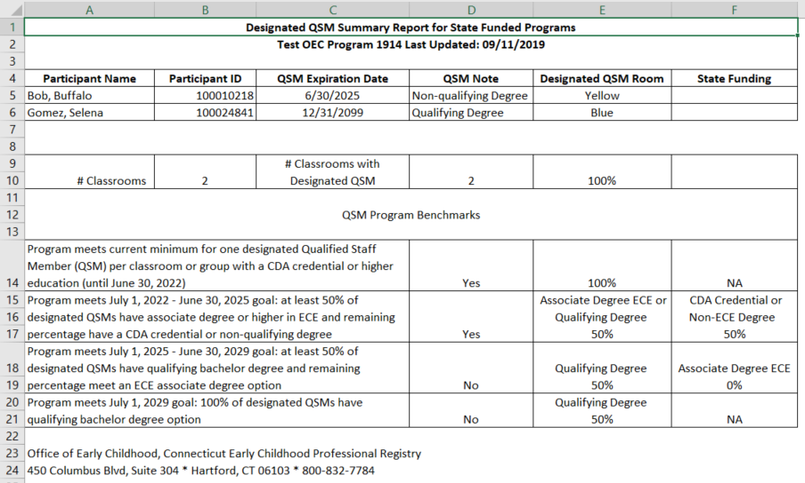

For questions regarding your staff and their qualifications in the Registry, contact your regional Education Advisor.

For questions or feedback about the tools, contact Margaret Gustafson Margaret.Gustafson@ct.gov

